1a

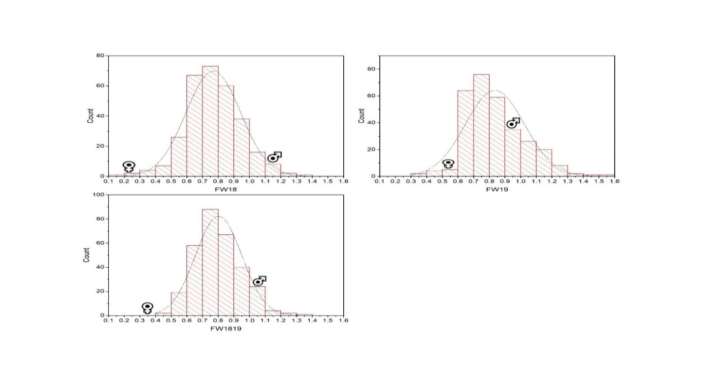

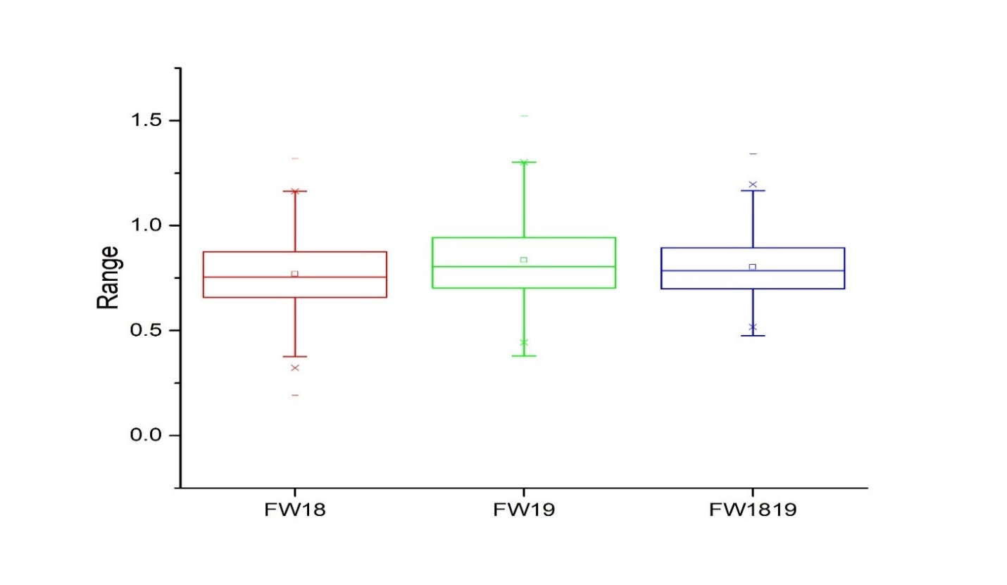
1b

1c

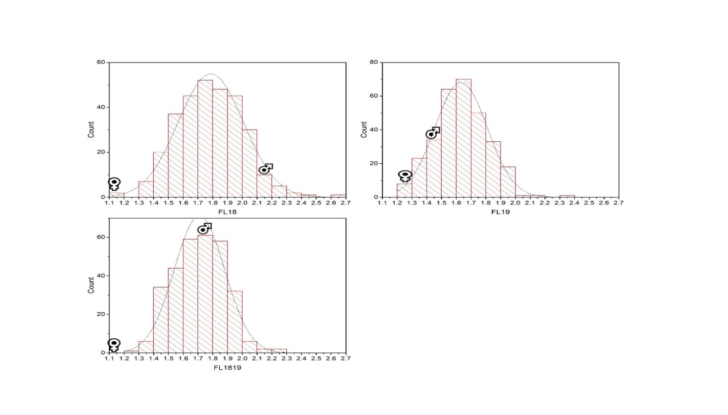

1d
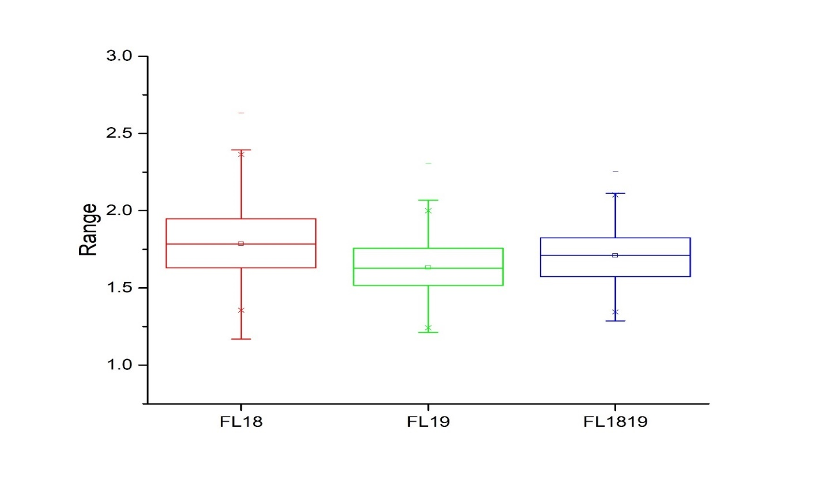

1e

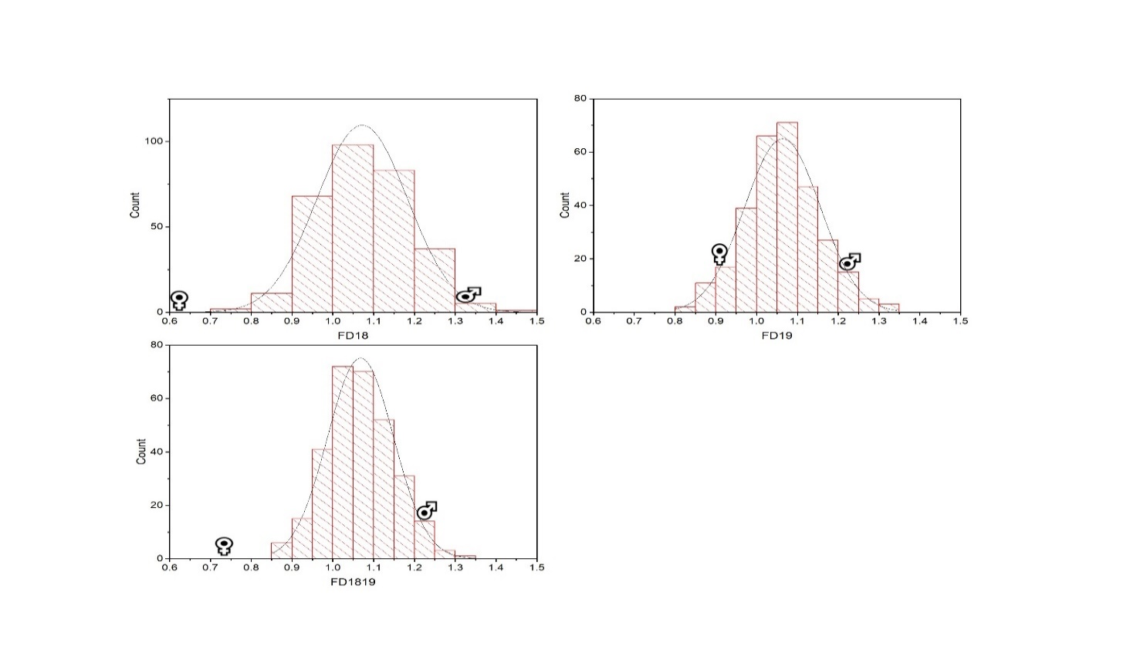

1f
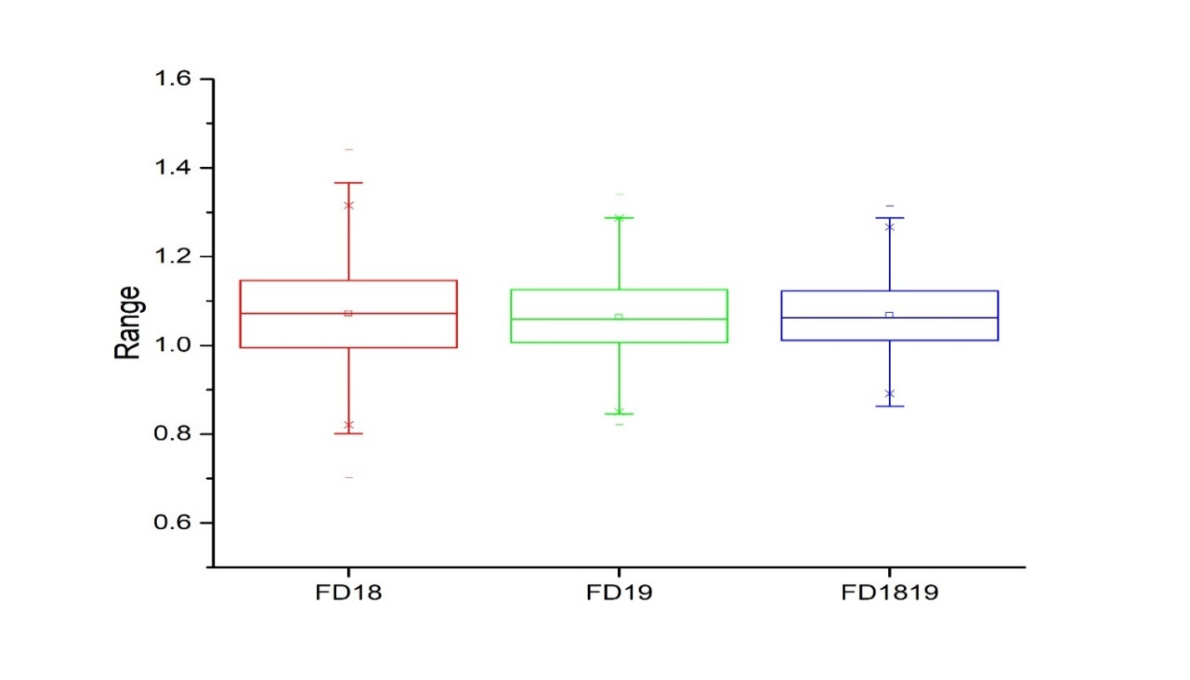

1g

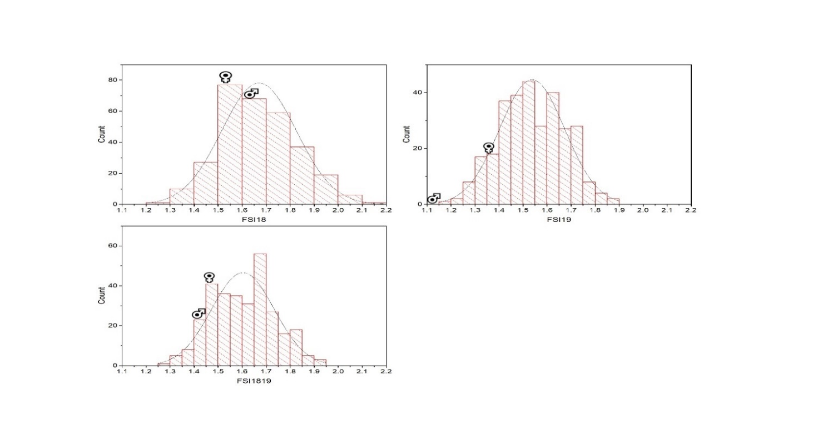

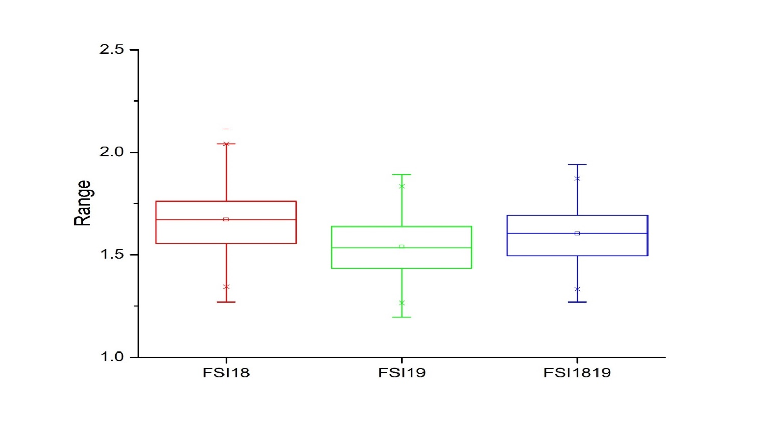
1h

1i

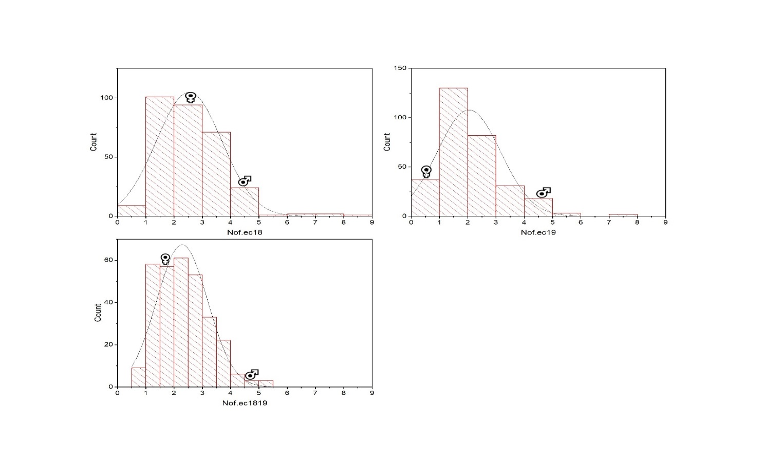

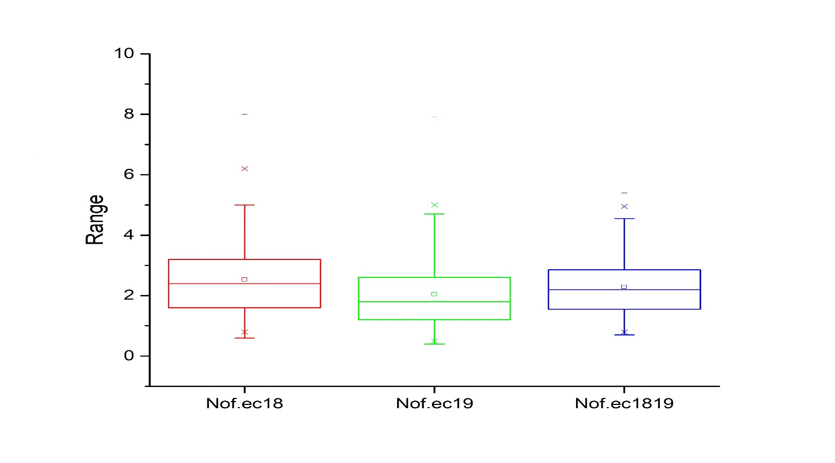
1j

1k

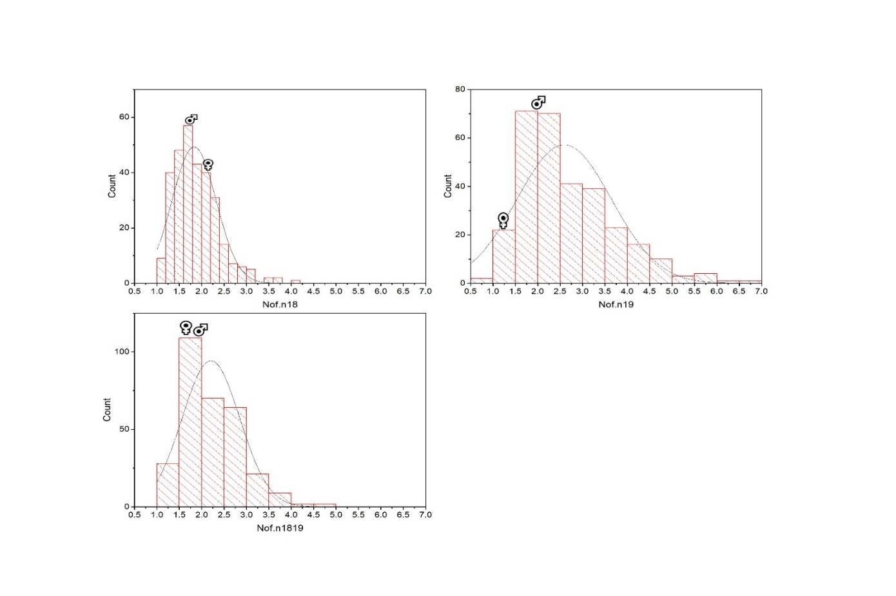

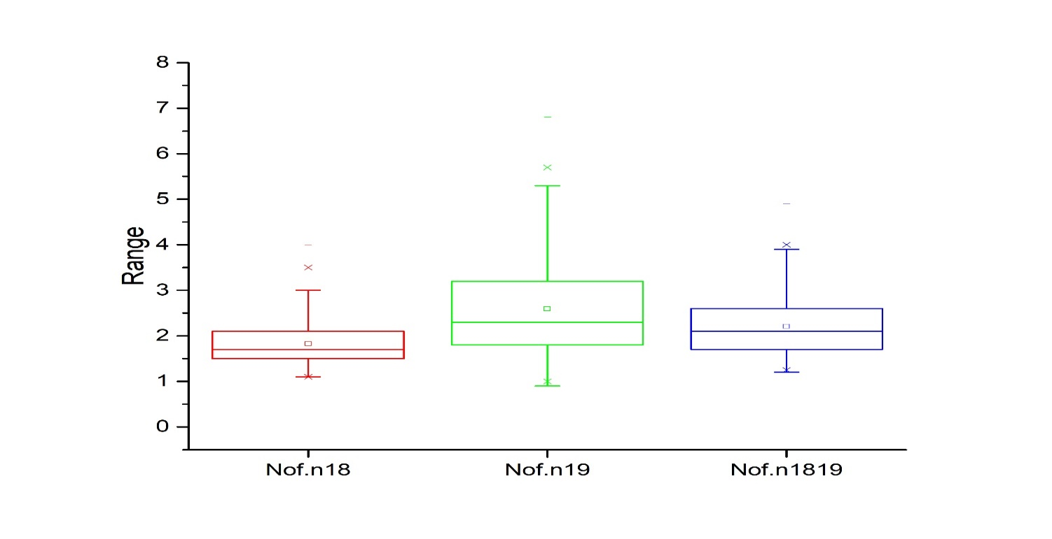
1l

1m

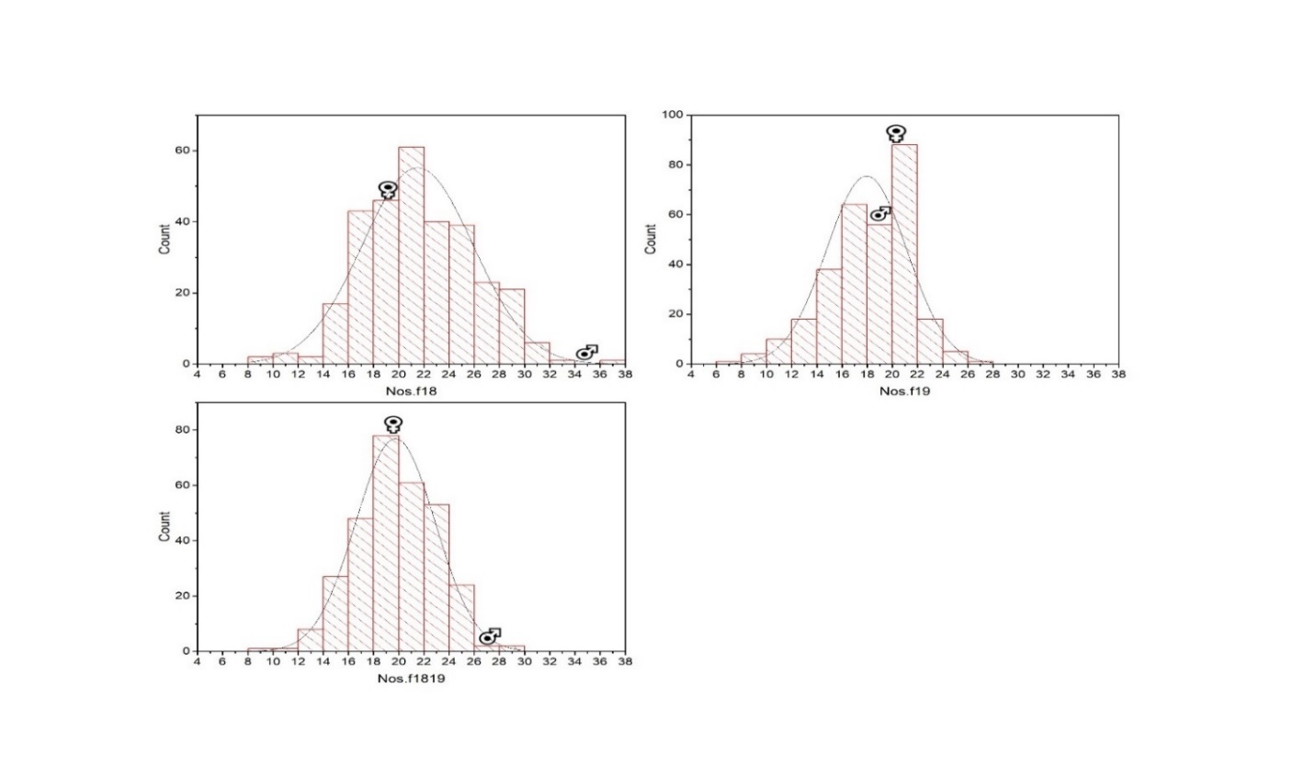

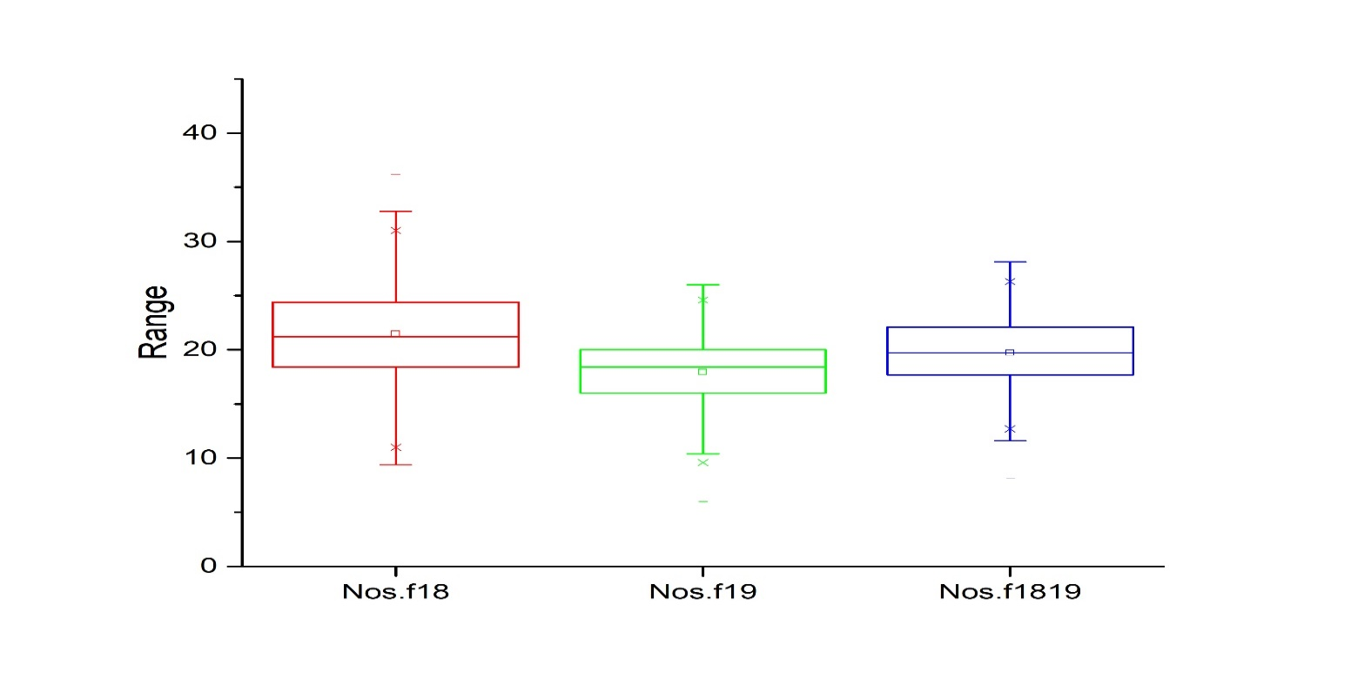
1n

1o

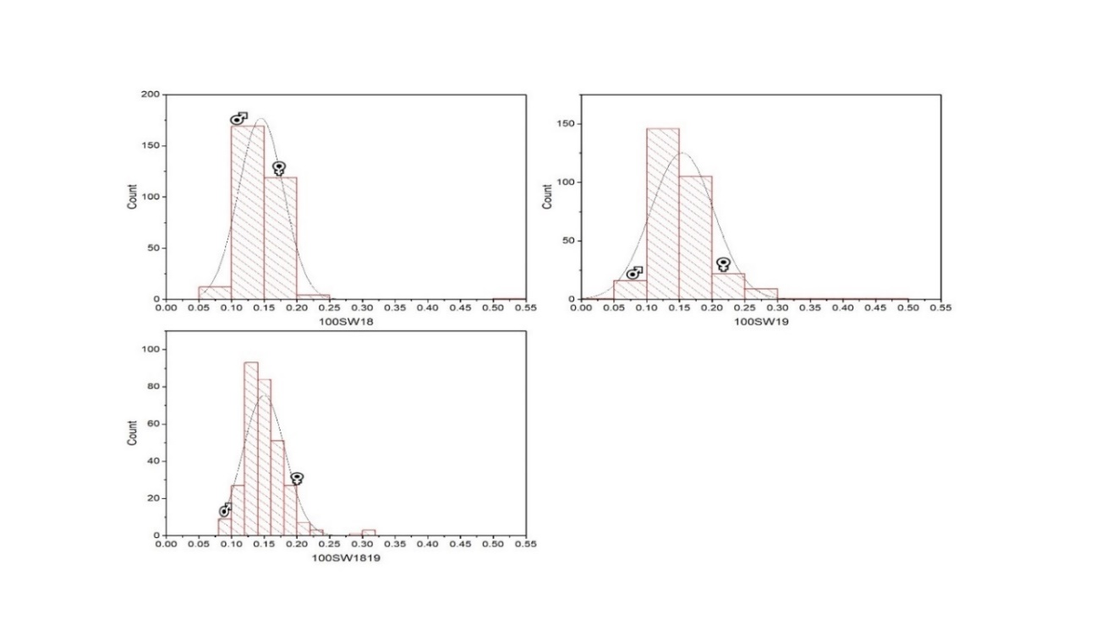

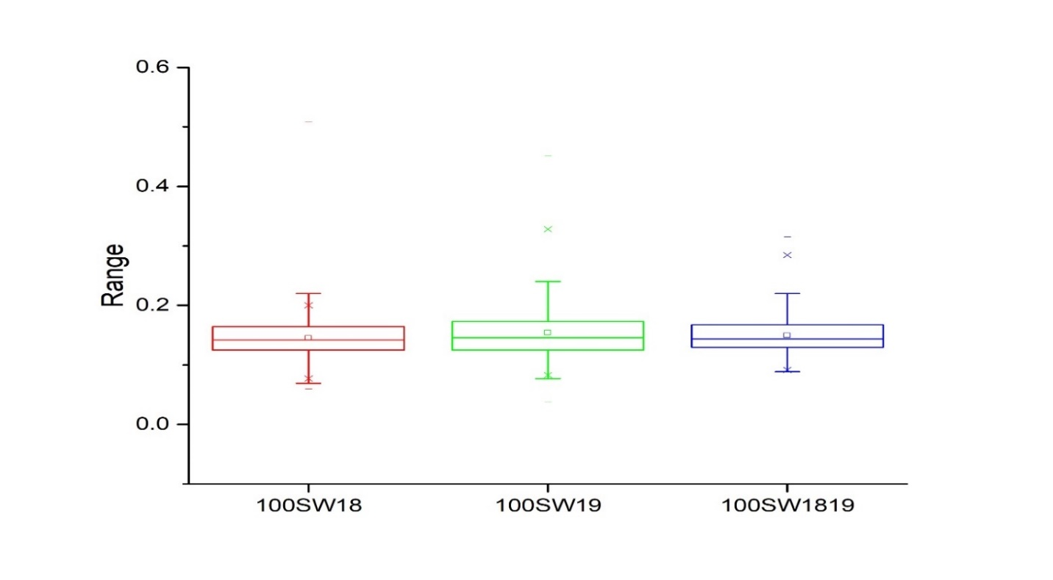
1p

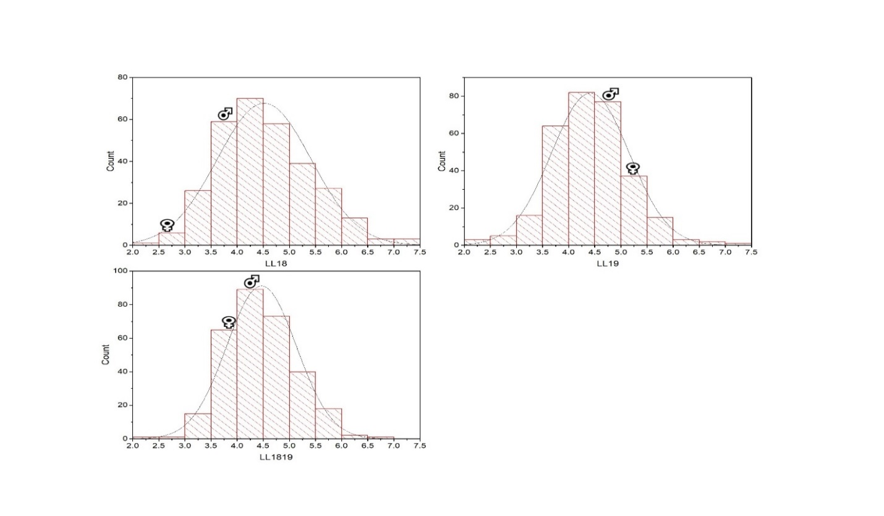
1q

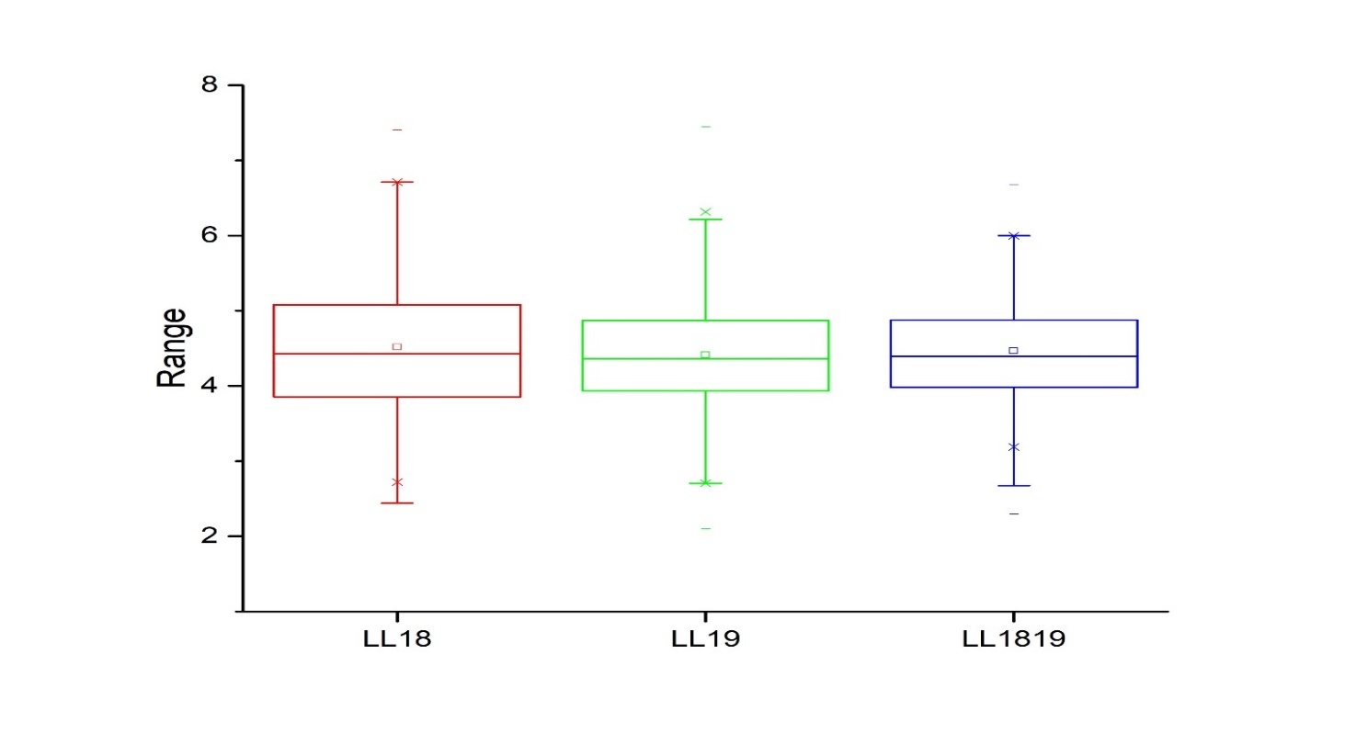
1r

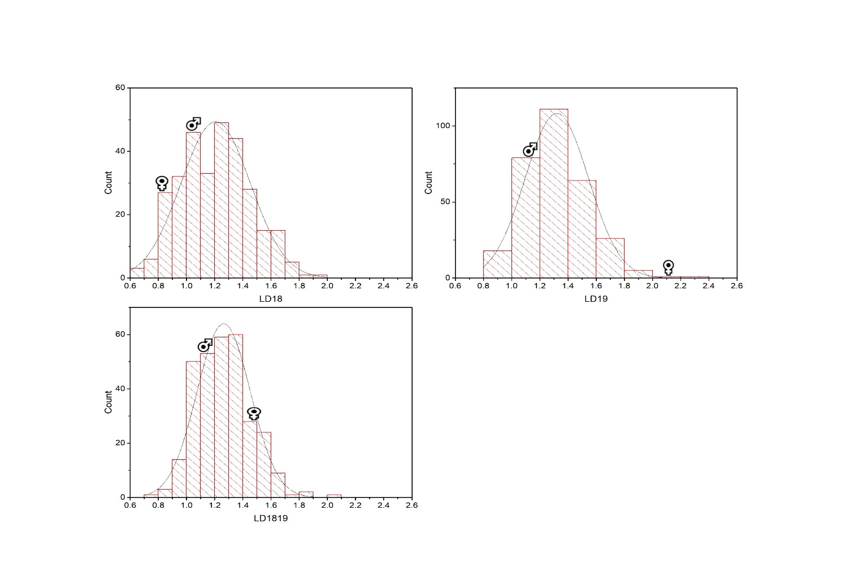
1s

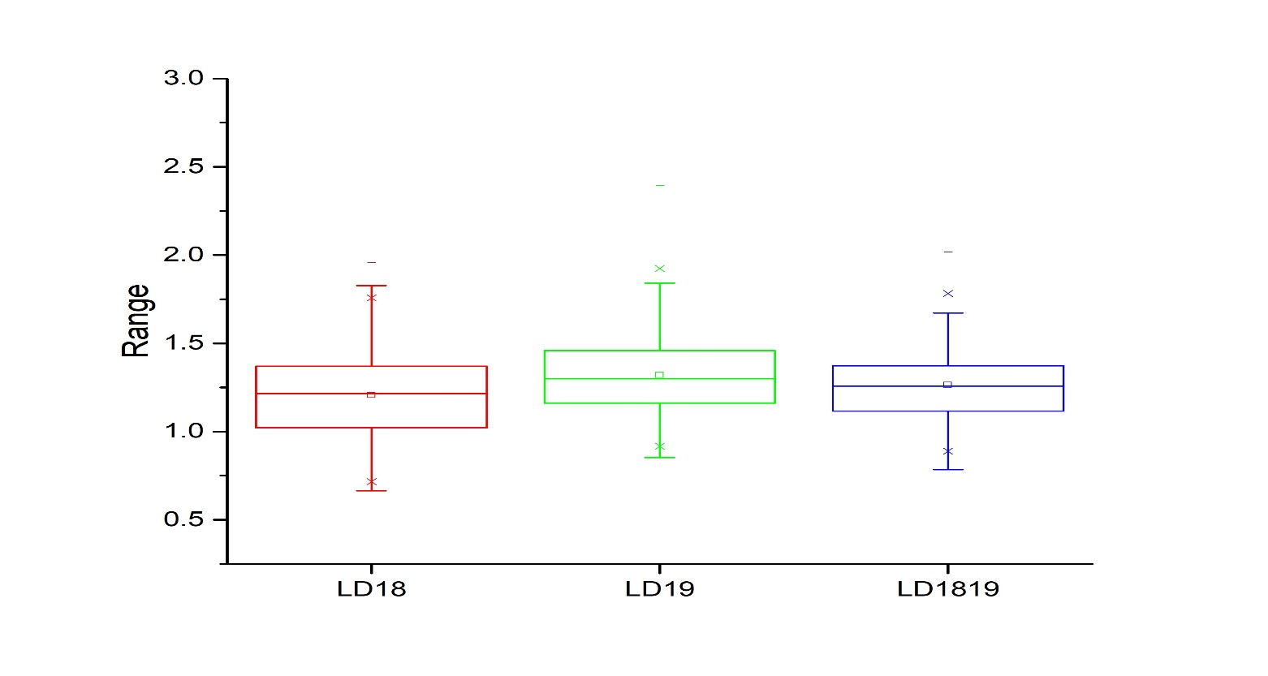
1t

1w

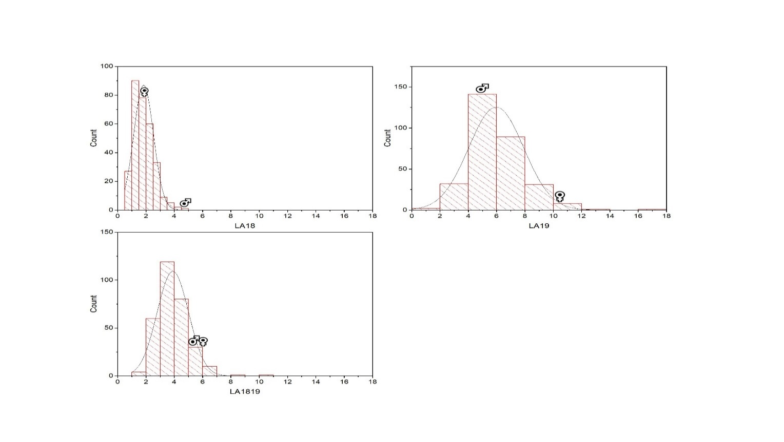

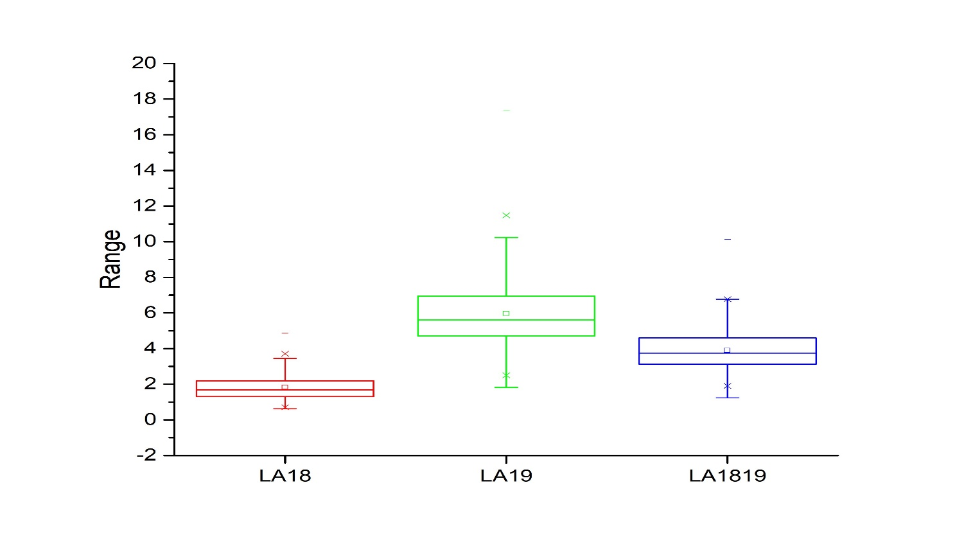
1x

1y
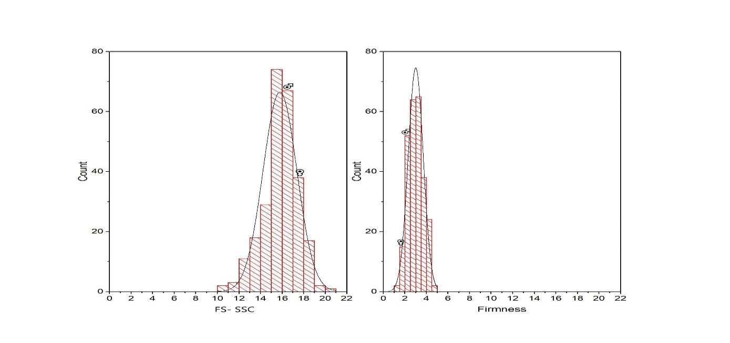

1z

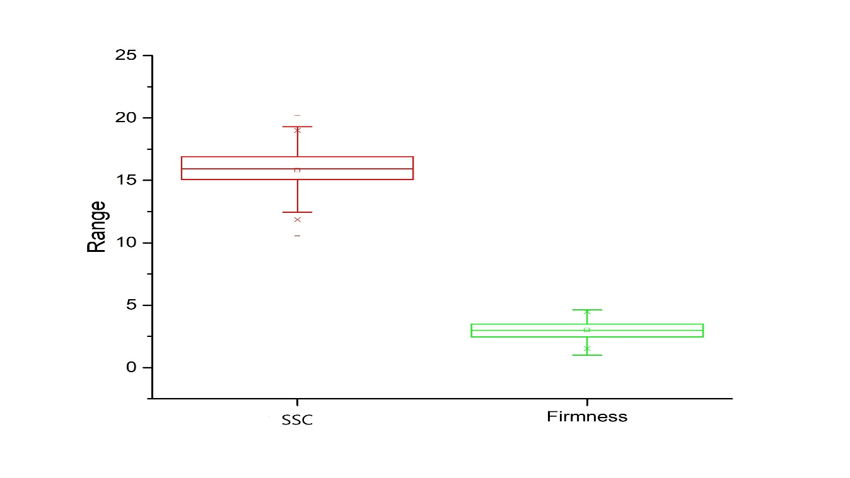

Figure S1(a-z) Frequency distribution histogram and Box chart diagram of 305 individuals from F₁ population for fruit morphological traits data based on continous two years collection 2018-2019 and their average as 1819 for fruit weight (FW), fruit length (FL), fruit diameter (FD), fruit shape index (FSI), number of fruits/end cluster (Nof/ec), number of fruits/node (Nof/n), number of seeds/fruit (Nos/f), 100 seed weight (100SW), leaf length (LL), leaf diameter (LD), leaf area (LA), fruit sweetness (SSC) and fruit firmness (FF) only in 2019. *In each histogram female and male parents position is indicated by signs. In each box chart, the lower and upper lines represent first and third quartiles, respectively, and the middle line shows the median.

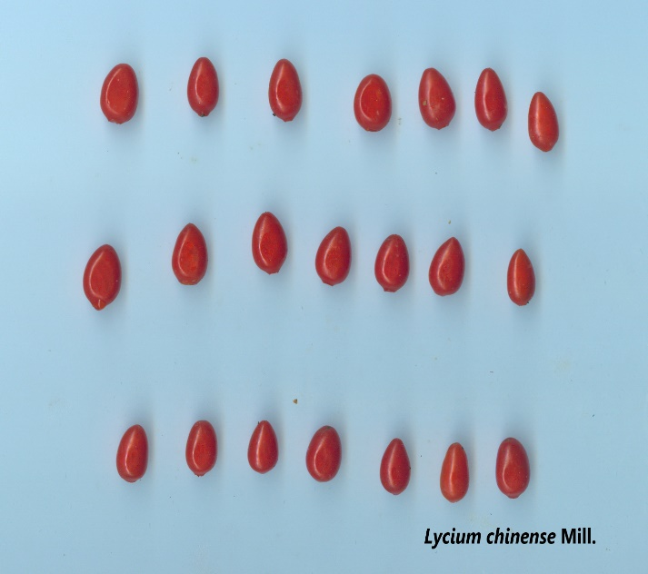
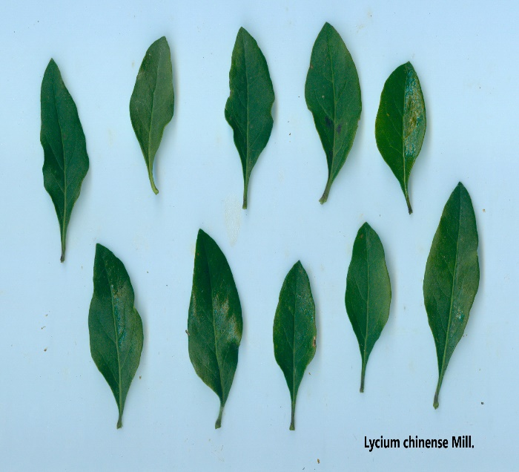
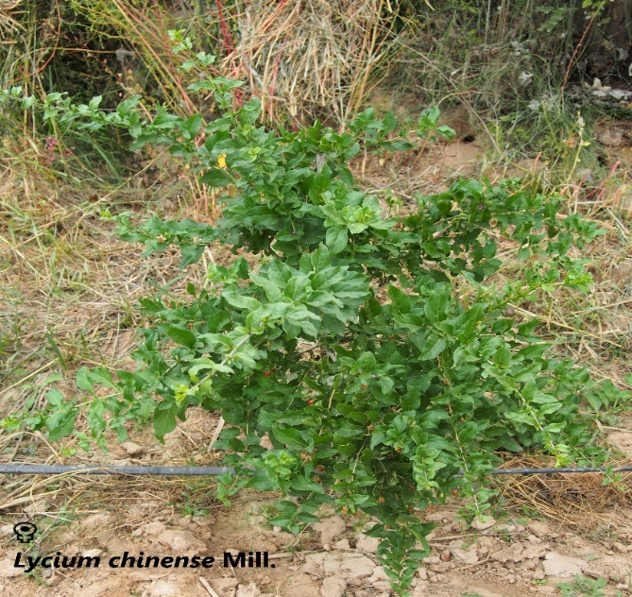
2a 2b 2c

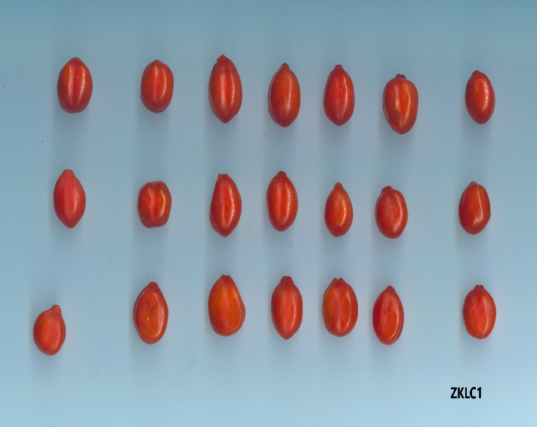
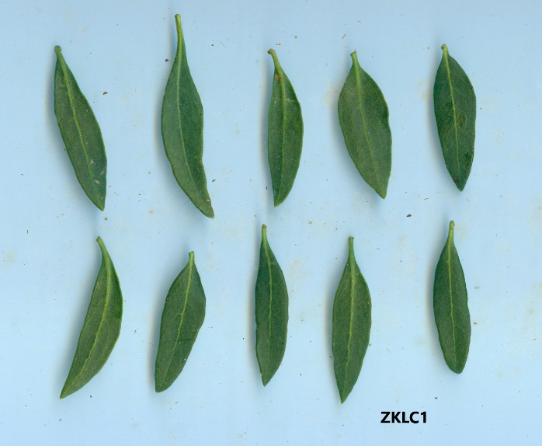
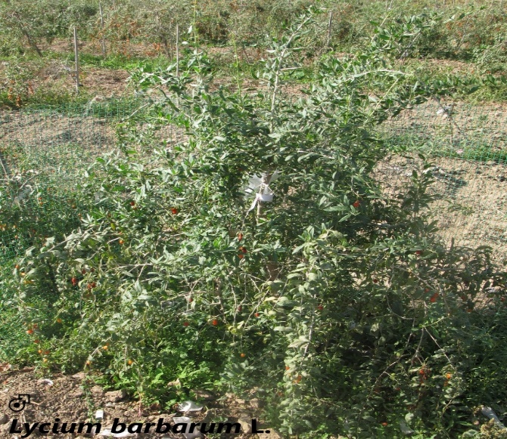
2d 2e 2f

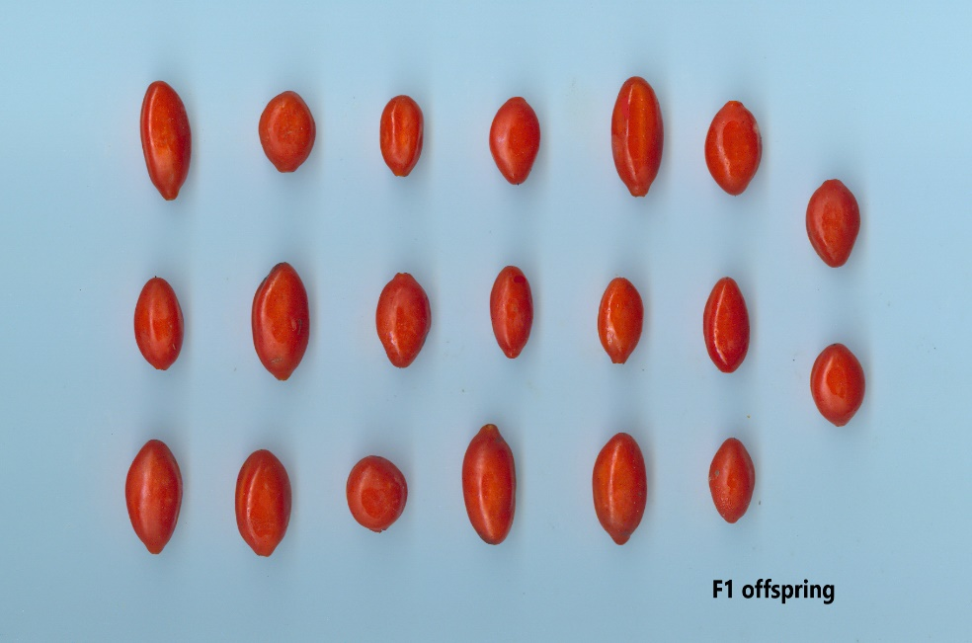
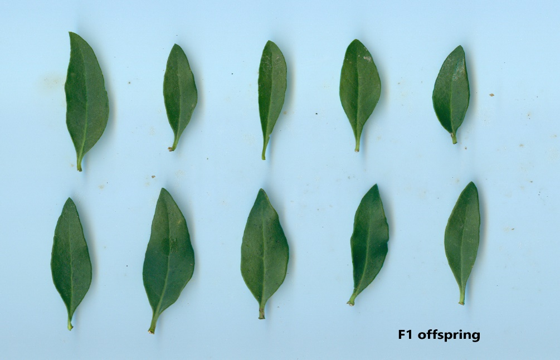
2g 2h

Figure S2(a-h) Female (Lycium chinense Mill.) and male (Lycium barbarum L.) parent plants, and their progeny pictures. *2a, female plant, 2b; leaves, 2c; fruits, 2d; male plant, 2e; leaves, 2f; fruits, 2g; F1 offspring leaves, 2h; F1 offspring fruits.

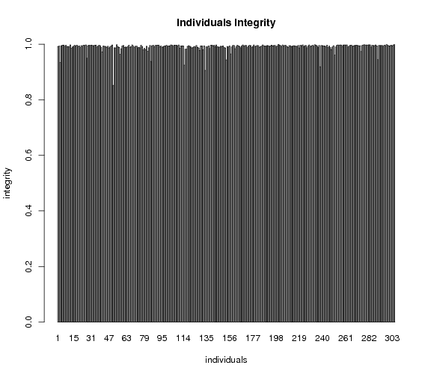
Figure S3 The marker integrities of each individual in mapping population. The x-axis indicates all 305 individuals along with specific codes name, while y-axis shows markers integrity.

